Lab 1: Basics of Python Programming

**References:**

1. Hands-on Python Tutorial, by Dr. Andrew N. Harrington, Loyola University Chicago. 2015.
2. Python for Data Science For Dummies, by Luca Massaron and John Paul Mueller, John Wiley & Sons, Inc., 2015.
3. Python Tutorials, by Guido van Rossum and Fred L. Drake, Jr., editor, Python Software Foundation. 2012.

Lab Practices

* 1. Simple Input and Output

1. Write a piece of code to ask the name of user and display it on the screen.

name = input("Enter your name: ")

print("Hey, it's", name, "-- hello!")

1. 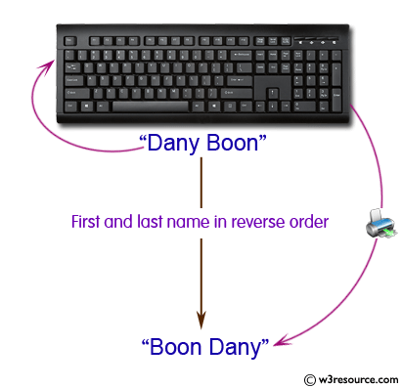Write a Python program which accepts the user's first and last name and print them in reverse order with a space between them.

fname = input("Input your First Name : ")

lname = input("Input your Last Name : ")

print ("Hello " + lname + " " + fname)

* 1. Simple Numerical Input and Output

1. Write a piece of code to ask user to enter two numbers and display the sum.

# Store input numbers

num1 = input('Enter first number: ')

num2 = input('Enter second number: ')

# Add two numbers

sum = float(num1) + float(num2)

# Display the sum

print('The sum of {0} and {1} is {2}'.format(num1, num2, sum))

* 1. Strings, Lists, and Function

1. 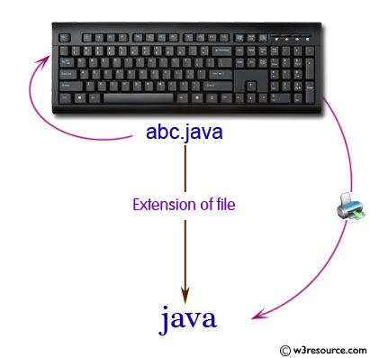Write a Python program to accept a filename from the user and print the extension of that.

filename = input("Input the Filename: ")

f_extns = filename.split(".")

print ("The extension of the file is : " + repr(f_extns[-1]))

1. 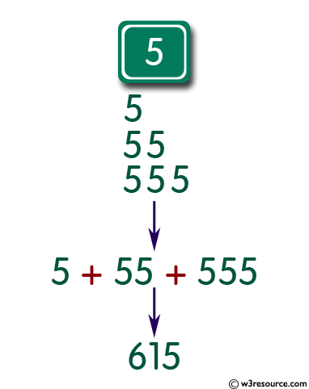Write a Python program that accepts an integer ($n$) and computes the value of $n+nn+nnn$.

a = int(input("Input an integer : "))

n1 = int( "%s" % a )

n2 = int( "%s%s" % (a,a) )

n3 = int( "%s%s%s" % (a,a,a) )

print (n1+n2+n3)

1. 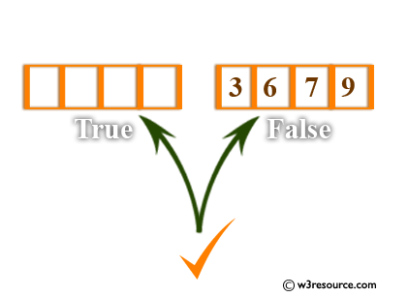Write a Python program to check a list is empty or not.

l = []

if not l:

print("List is empty")

1. Write a Function to find the list of words that are longer than n from a given list of words.

def long_words(n, str):

word_len = []

txt = str.split(" ")

for x in txt:

if len(x) > n:

word_len.append(x)

return word_len

text = input("Input your text: ")

n = int(input("Input the number letter in words you want to find: "))

print(long_words(n, text))

1. 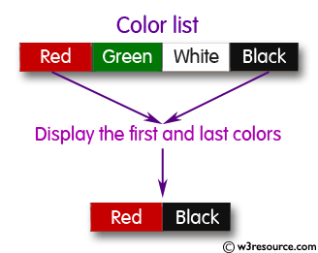Write a Python program to display the first and last colors from the following list: color_list = ["Red","Green","White" ,"Black"]

color_list = ["Red","Green","White" ,"Black"]

print( "%s %s"%(color_list[0],color_list[-1]))

* 1. Loop and List

1. Use for loop and write a piece of code to ask user to enter the number of students and their marks, and calculate the average mark of class.

n=int(input("Enter the number of students: "))

a=[]

for i in range(0,n):

elem=int(input("Enter mark: "))

a.append(elem)

avg=sum(a)/n

print("Average of marks in the list", round(avg,2))

1. Revise the code using while loop.

n=int(input("Enter the number of students: "))

a=[]

i = 0

while (i<n):

elem=int(input("Enter mark: "))

a.append(elem)

i = i + 1

avg=sum(a)/n

print("Average of marks in the list", round(avg,2))

1. Write a Python program to count the number of strings where the string length is 2 or more and the first and last character are same from a given list of strings.

def match_words(words):

ctr = 0

for word in words:

if len(word) > 1 and word[0] == word[-1]:

ctr += 1

return ctr

print(match_words(['abc', 'xyz', 'aba', '1221']))

1. Revise the programme in C to get the list from user.

def match_words(words):

ctr = 0

for word in words:

if len(word) > 1 and word[0] == word[-1]:

ctr += 1

return ctr

n = int(input("Enter the number of words you like to test: "))

a=[]

for i in range(0,n):

wrd = input("Enter a word: ")

a.append(wrd)

print(match_words(a))

1. 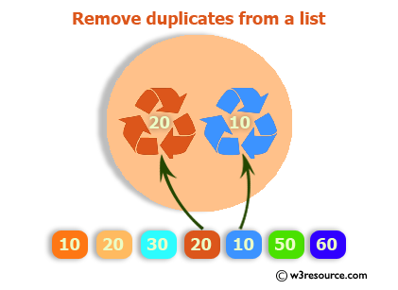Write a Python program to remove duplicates from a list.

a = [10,20,30,20,10,50,60,40,80,50,40]

dup_items = set()

uniq_items = []

for x in a:

if x not in dup_items:

uniq_items.append(x)

dup_items.add(x)

print(dup_items)

1. Write a Python function that takes two lists and returns True if they have at least one common member.

def common_data(list1, list2):

result = False

for x in list1:

for y in list2:

if x == y:

result = True

return result

print(common_data([1,2,3,4,5], [5,6,7,8,9]))

print(common_data([1,2,3,4,5], [6,7,8,9]))

1. 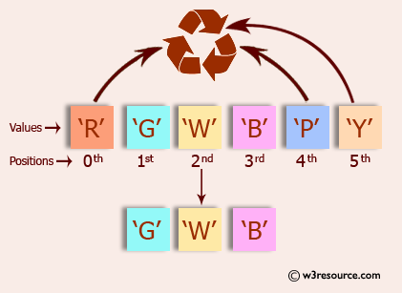Write a Python program to print a specified list after removing the 0th, 4th and 5th elements.

color = ['Red', 'Green', 'White', 'Black', 'Pink', 'Yellow']

color = [x for (i,x) in enumerate(color) if i not in (0,4,5)]

print(color)

1. Revise the programme in G to receive the input list from user.
   1. Conditional Decision/Branching
2. Improve the code in 1.4 (A) to calculate the average of odd marks, only.

n=int(input("Enter the number of students: "))

c=0

a=[]

odds=[]

for i in range(0,n):

elem=int(input("Enter mark: "))

a.append(elem)

if elem%2 == 1:

odds.append(elem)

c+=1

avg=sum(odds)/c

print("Average of odd marks in the list", round(avg,2))

1. Write a Python program to print the numbers of a specified list after removing even numbers from it.

n=int(input("Enter the number of elements: "))

num = []

for i in range(0,n):

elem=int(input("Enter a number: "))

num.append(elem)

odds = [x for x in num if x%2!=0]

print(odds)

1. Write a password checking programme to simulate the login procedure of a system. The system can grant the user access if the password is correct (simply display a proper message).

user_input = input("Enter the password: ")

system_pw = "pw@python"

if user_input == system_pw:

print("Welcome to the system!")

else:

print("Sorry, the password is wrong. You are not permitted to enter the system.")

1. Write a Python program to find the second smallest number in a list.

def second_smallest(numbers):

a1, a2 = float('inf'), float('inf')

for x in numbers:

if x <= a1:

a1, a2 = x, a1

elif x < a2:

a2 = x

return a2

print(second_smallest([-1, 4, -3, 1, 5, 2, -8, -2, 0]))

* 1. Use of extra packages

1. Write a Python program to display the current date and time.

import datetime

now = datetime.datetime.now()

print ("Current date and time : ")

print (now.strftime("%Y-%m-%d %H:%M:%S"))

1. Write a Python program which accepts the radius of a circle from the user and compute the area.

from math import pi

r = float(input ("Input the radius of the circle : "))

a = pi * r**2

print ("The area of the circle" + " is: " + str(a))

1. 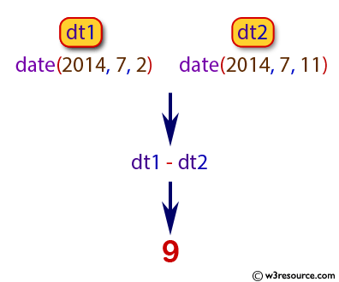Write a Python program to calculate number of days between two dates.

from datetime import date

f_date = date(2014, 7, 2)

l_date = date(2014, 7, 11)

delta = l_date - f_date

print(delta.days)

Further Exercises

1. Write code to access a favourite webpage and extract some text from it. For example, access a weather site and extract the forecast top temperature for your town or city today.
2. Write a function unknown() that takes a URL as its argument, and returns a list of unknown words that occur on that webpage. In order to do this, extract all substrings consisting of lowercase letters (using re.findall()) and remove any items from this set that occur in the Words Corpus (nltk.corpus.words). Try to categorize these words manually and discuss your findings.
3. Make a Rock, Paper, Scissors game and play against the computer.
4. Create a program to generate passwords for you.